Dear Neighbour,

We are writing to you to inform you of progress on the new leisure centre.

We are pleased to announce that right on programme the steel frame of the new leisure centre has been completed. It has had many checks and independent verification to confirm it is lined, levelled, straight and true and is now receiving further trades such as the metal first floor decking sheets.

These sheets, once firmly fixed, will be the ‘shutter’ for the concrete topping that will become the first floor.
This concrete pour and subsequent finishing is looking likely to occur next week, but this is entirely dependent on the most unpredictable of things…the weather.

If the heat wave continues as predicted we should be able to pour and finish the concrete within our allocated planning hours of 8am to 6pm, however, if the weather turns, the process can exceed these hours. If this does happen we would like to forewarn you that there will be activity on site.

The activity itself will be fully managed by Pellikaan and consist of a few operatives ‘pan floating’ the concrete, a process which generates little noise so we are hoping it doesn’t cause any inconvenience.

As an aside we currently have the new pool on test and it is looking really good, meeting our exacting demands for tolerance and, above all else, showing no signs of leaks. Once the pool has passed this test we will then test the balance tank to the same standards, using the existing water in the pool to avoid waste, after this the water will be recycled and used for the duration of the project.

We are also pleased to announce that we have scored a rather good 90% on our latest inspection from the Considerate Constructors Scheme, please contact us directly if you would like to hear more.

Please feel free to email us directly on info@pellikaan.com or call us on 0208 392 9536.

Yours Sincerely,
Andrew Laslett.

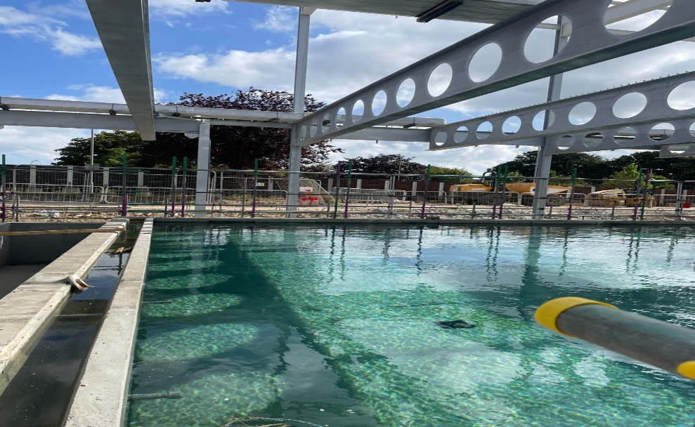 Pool filling and testing, July 2026.

